“SMART KITCHEN SYSTEM”

A course project report submitted in partial fulfillment of requirement for the completion of **Smart System Design** course

By

NAME: H.NO:

***MAHATHI 2203A51155***

***GHUFRAN AHMED 2203A51477***

***SAI HARSHITH 2203A51129***

***DURGA REDDY 2203A51629***

Under the guidance of faculty in-charges

**Mr.P.RamChandar Rao, Assistant Professor**

**Mr.Y.Srikanth, Assistant Professor**

**Department of ECE.**



SR University, Ananthasagar, Hasanparthy

Warangal Urban 506371, Telangana, India

ACKNOWLEDGEMENT:

It is a great privilege for us to express our profound gratitude to our respected teachers Mr.P.RamChandar Rao Assistant Professor, & **Mr.Y.Srikanth, Assistant Professor** Department of ECE , SR University, for their constant guidance, valuable suggestions, supervision and inspiration throughout the course work without which it would have been difficult to complete the work within scheduled time. We would like to express our gratitude towards Other Faculty for his/her kind co-operation and encouragement which helped me in completion of this project. We are also indebted to the Head of the Department, Department of ECE, SR University for permitting us to pursue the project. We would like to take this opportunity to thank all the respected teachers of this department for being a perennial source of inspiration and showing the right path at the time of necessity.

**CONTENTS**

***ABSTRACT ii***

**Chapter No. Title Page No.**

**1 INTRODUCTION** 01

1.1 Introduction 02

1.2 Objectives 03

**2 Project description** 04

2.1 Block diagram of project 04

2.2 Description of block diagram 05

2.3 Hardware description 05

2.3.1 Arduino Uno 06

2.3.2 12DC motor 0

2.3.3 12V Axial Fan 0

2.3.4 L298N Motor driver 05

2.3.5 MQ135 sensor 07

2.3.6 Load cell

2.3.7 HX711 Driver

2.3.8 Flame sensor

2.3.9 16*2 LCD

2.3.10 Buzzer

2.4 Software description

**3. CIRCUIT DIAGRAM AND DISCRIPTION** 12

3.1 Working 12

3.2 Results 12

3.3 Advantages 13

3.4 Disadvantages 13

**4. CONCLUSION**

4.1 Conclusion 14

4.2 Future scope 14

**BIBLIOGRAPHY** 15

Abstract:-Liquefied Petroleum Gas (LPG) is widely used in households, but the consumer is unaware of the daily rate of consumption and the time frame when he/she needs to cook. Fire explosion and Gas leakages results a serious problem in household and other areas where household gas is used.

This project has three parts, one part deals with the percentage of gas remaining in the cylinder which is found using a sensor called load cell and the percentage of gas remaining in the cylinder shows in lcd and when the gas leaks the led will on and alert buzzer, when the Fire explosion takes places the led will on and alert buzzer and axial fan will rotate and the window will open.

**1.INTRODUCTION:-**

Gas leakage is a serious problem and nowadays it is observed in many places like residences, industries, and vehicles like Compressed Natural Gas (CNG), buses, cars, etc. It is noticed that due to gas leakage, dangerous accidents occur, LPG cylinder plays a major role. LPG is an odourless gas which is a mixture of propane and butane. It contains both saturated and unsaturated hydrocarbons. Ethyl Mercaptan is the stanching agent which is used to impart odour to the odourless LPG. LPG is liquefied under moderate pressure and has replaced many conventional fuel systems in household and commercial sectors. Though it is one of the most commonly used fuels, it has an explosive range of 1.8%9.5% volume of gas in air.The main application of the LPG is that it is used in the place of chlorofluro carbon which cause great damage to the ozone layer. LPG is packed into 3 categories according to the weight of the LPG in the cylinder: Household, Commercial and Industrial. The Household category of LPG cylinder contains 14.2 kg LPG in the cylinder. Similarly, the Commercial and Industrial categories of LPG cylinders contain 19 and 35 kg of LPG respectively. [1]

The LPG is filled only up to 85% in these cylinders above which will be vapours. This is due to the expansion property of the LPG and consequently, contributes as a safety precaution to avoid any hazards. For every 1 rise in temperature, the pressure of LPG inside the cylinder will increase by 15 kg/cm3. This makes LPG a very hazardous and extremely inflammable gas. The Liquefied petroleum gas (LPG), or propane, is a flammable mixture of hydrocarbon gases used as fuel in many applications like homes, hostels, industries, automobiles, and vehicles because of its desirable properties which include high calorific value, less smoke, less soot, and meager harm to the environment. Liquid petroleum gas (LPG) is highly inflammable and can burn even at some distance from the source of leakage. This energy source is primarily composed of propane and butane which are highly flammable chemical compounds.

These gases can catch fire easily. In homes, LPG is used mainly for cooking purposes. When a leak occurs, the leaked gases may lead to an explosion. Gas leakage leads to various accidents resulting in both material loss and human injuries. Home fires have been occurring frequently and the threat to human lives and properties has been growing in recent years. The risks of explosion, fire, suffocation is based on their physical properties such toxicity, flammability, etc. The number of deaths due to the explosion of gas cylinders has been increasing in recent years. The Bhopal gas tragedy is an example of accidents due to gas leakage. The reason for such explosions is due to substandard cylinders, old valves, no regular checking of gas cylinders, worn out regulators and a lack of awareness of handling gas cylinders. Therefore, the gas leakage should be detected and controlled to protect people from danger. An odorant such as ethane thiol is added to LPG, so that leaks can be detected easily by most people. However, some people who have a reduced sense of smell may not be able to rely upon this inherent safety mechanism. A gas leakage detector becomes vital and helps to protect people from the dangers of gas leakage.

So this project deals with finding the level of gas in the cylinder which is found using a sensor called load cell and the percentage of gas remaining in the cylinder shows in lcd and when the gas leaks the led will on and alert buzzer, when the Fire explosion takes places the led will on and alert buzzer and axial fan will rotate and the window will open.

**OBJECTIVES:**

* The objective of this project is to implement a low cost , reliable, and it is a type of Smart Kitchen System it prevents from fire accidents and atmosphere damage.

**2.PROJECT DESCRIPTION:-**

**2.1 BLOCK DIAGRAM OF THE PROJECT**

As shown in the above schematic diagram it mainly consists of an arduino, three sensors and two actuators. The three sensors are flame detector sensor, load cell and a gas sensor that is mq135. These sensors are connected to arduino. Whenever the flame sensor detects the fire then immediately it sends an information to arduino. And the other sensor is mq2. If any gas leaks then it immediately sends an information to arduino and then it alerts us and switch on’s the fan. And the actuators are DC motor it helps to open the window and Exhaust fan helps the gas to move out .The block diagram of the project is shown in fig. 2.1

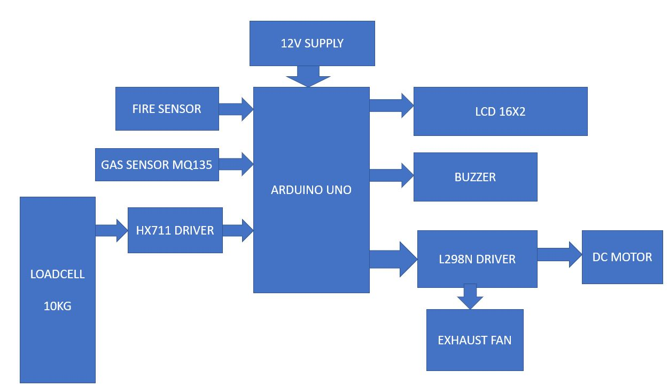

**2.2 HARDWARE DESCRIPTION**

**Applications:**

1.Arduino Uno

2.12v DC motor

3.12V Axial Fan

4. L298N Motor driver

5.MQ135 sensor

6. Load cell

7.HX711 Driver

8.Flame sensor

9.16*2 LCD

10 .Buzzer

**1.Arduino UNO**

The Arduino Uno is a microcontroller board based on the ATmega328 (datasheet). It has 14 digital input/output pins (of which 6 can be used as PWM outputs), 6 analog inputs, a 16 MHz ceramic resonator, a USB connection, a power jack, an ICSP header, and a reset button. It contains everything needed to support the microcontroller; simply connect it to a computer with a USB cable or power it with a AC-to-DC adapter or battery to get started. The Uno differs from all preceding boards in that it does not use the FTDI USB-to-serial driver chip. Instead, it features the Atmega16U2 (Atmega8U2 up to version R2) programmed as a USB-to-serial converter. Revision 2 of the Uno board has a resistor pulling the 8U2 HWB line to ground, making it easier to put into DFU mode. Revision 3 of the board has the following new features: 1.0 pinout: added SDA and SCL pins that are near to the AREF pin 3 and two other new pins placed near to the RESET pin, the IOREF that allow the shields to adapt to the voltage provided from the board. In future, shields will be compatible both with the board that use the AVR, which operate with 5V and with the Arduino Due that operate with 3.3V. The second one is a not connected pin, that is reserved for future purposes. Stronger RESET circuit. Atmega 16U2 replace the 8U2. "Uno" means one in Italian and is named to mark the upcoming release of Arduino 1.0. The Uno and version 1.0 will be the reference versions of Arduino, moving forward. The Uno is the latest in a series of USB Arduino boards, and the reference model for the Arduino platform; for a comparison with previous versions, see the index of Arduino boards.

Microcontroller ATmega328

Operating Voltage 5V

Input Voltage (recommended) 7-12V

Input Voltage (limits) 6-20V

Digital I/O Pins 14 (of which 6 provide PWM output)

Analog Input Pins 6

DC Current per I/O Pin 40 mA

DC Current for 3.3V Pin 50 mA

Flash Memory 32 KB of which 0.5 KB used by bootloader

SRAM 2 KB (ATmega328)

EEPROM 1 KB (ATmega328)

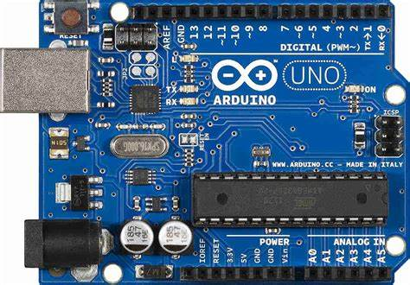

Fig. 2.2 Arduino Uno

**2. 12v DC motor**

A **DC motor** is any of a class of rotary [electrical motors](https://en.wikipedia.org/wiki/Electrical_motor) that converts direct current (DC) electrical energy into mechanical energy. The most common types rely on the forces produced by induced magnetic fields due to flowing current in the coil. Nearly all types of DC motors have some internal mechanism, either electromechanical or electronic, to periodically change the direction of current in part of the motor.

DC motors were the first form of motors widely used, as they could be powered from existing direct-current lighting power distribution systems. A DC motor's speed can be controlled over a wide range, using either a variable supply voltage or by changing the strength of current in its field windings. Small DC motors are used in tools, toys, and appliances. The [universal motor](https://en.wikipedia.org/wiki/Universal_motor), a lightweight [brushed](https://en.wikipedia.org/wiki/Brush_(electric)) motor used for portable power tools and appliances can operate on direct current and alternating current. Larger DC motors are currently used in propulsion of electric vehicles, elevator and hoists, and in drives for steel rolling mills. The advent of [power electronics](https://en.wikipedia.org/wiki/Power_electronics) has made replacement of DC motors with [AC motors](https://en.wikipedia.org/wiki/AC_motors) possible in many applications.

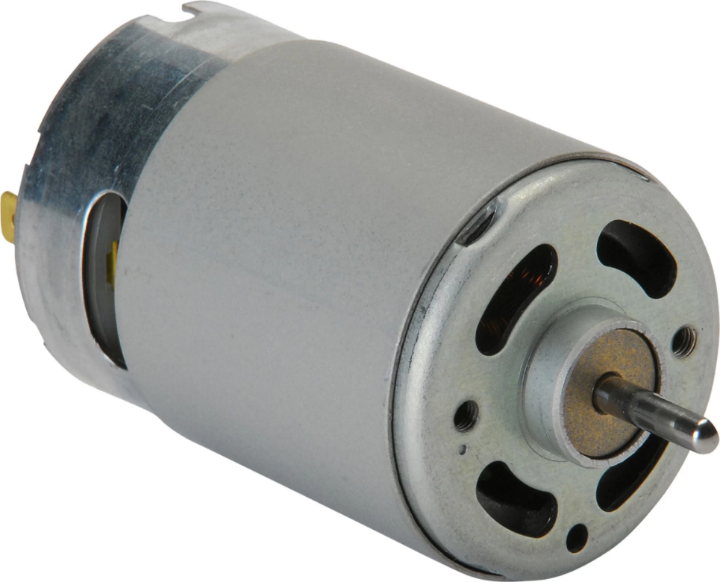

**3. 12V Axial Fan**

An **axial fan** is a type of fan that causes gas to flow through it in an axial direction, [parallel](https://en.wikipedia.org/wiki/Parallel_(geometry)) to the shaft about which the blades rotate. The flow is axial at entry and exit. The fan is designed to produce a [pressure](https://en.wikipedia.org/wiki/Pressure) difference, and hence [force](https://en.wikipedia.org/wiki/Force), to cause a flow through the fan. Factors which determine the performance of the fan include the number and shape of the blades. [Fans](https://en.wikipedia.org/wiki/Mechanical_fan) have many applications including in [wind tunnels](https://en.wikipedia.org/wiki/Wind_tunnels) and [cooling towers](https://en.wikipedia.org/wiki/Cooling_towers). Design parameters include [power](https://en.wikipedia.org/wiki/Power_(physics)), [flow rate](https://en.wikipedia.org/wiki/Flow_measurement), [pressure](https://en.wikipedia.org/wiki/Pressure) rise and [efficiency](https://en.wikipedia.org/wiki/Efficiency).[[1]](https://en.wikipedia.org/wiki/Axial_fan_design#cite_note-Yahya2010-1)

Axial fans generally comprise fewer blades (two to six) than [ducted fans](https://en.wikipedia.org/wiki/Ducted_fan). Axial fans commonly have larger radius and lower speed (ω) than ducted fans (esp. at similar power. Stress proportional to r^2).

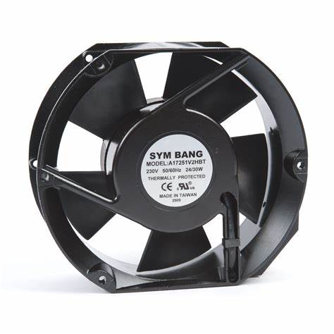

**4. L298N Motor driv**er

This **L298N Motor Driver Module** is a high power motor driver module for driving DC and Stepper Motors. This module consists of an L298 motor driver IC and a 78M05 5V regulator. **L298N Module** can control up to 4 DC motors, or 2 DC motors with directional and speed control.

### **Features & Specifications**

* Driver Model: L298N 2A
* Driver Chip: Double H Bridge L298N
* Motor Supply Voltage (Maximum): 46V
* Motor Supply Current (Maximum): 2A
* Logic Voltage: 5V
* Driver Voltage: 5-35V
* Driver Current:2A
* Logical Current:0-36mA
* Maximum Power (W): 25W
* Current Sense for each motor
* Heatsink for better performance
* Power-On LED indicator

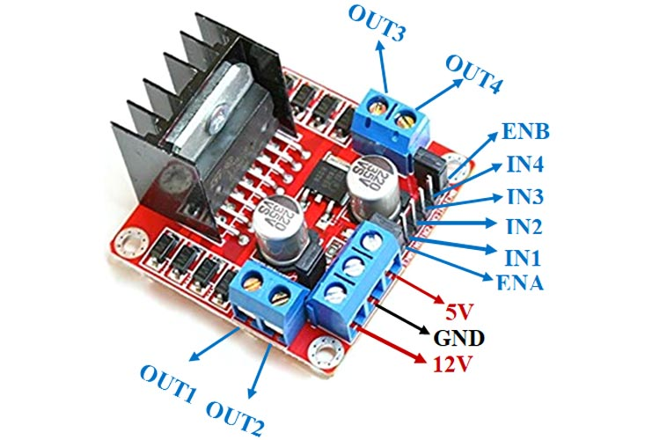

**5.MQ135 sensor**

Device that is used to detect or measure or monitor the gases like ammonia, benzene, sulfur, carbon dioxide, smoke, and other harmful gases are called as an air quality gas sensor. The MQ135 air quality sensor, which belongs to the series of MQ gas [sensors](https://www.elprocus.com/types-of-sensors-with-circuits/), is widely used to detect harmful gases, and smoke in the fresh air. This article gives a brief description of how to measure and detect gases by using an MQ135 air quality sensor.

The alternatives for the MQ135 air quality sensor/detector are MQ-2 (methane, LPG, butane, and smoke), MQ-3 (alcohol, smoke, and ethanol), [MQ-4 (CNG gas and methane)](https://www.elprocus.com/mq4-methane-gas-sensor/), MQ-5 (natural gas, and LPG), MQ-6 (butane and LPG), MQ-7 (CO), MQ-8 (Hydrogen), MQ-9 (CO, and flammable gases), MQ131 (ozone), MQ136 (Hydrogen sulfide gas), MQ137 (ammonia), MQ138 (benzene, alcohol, propane, toluene, formaldehyde gas, and hydrogen), MQ214 (methane, and natural gas), MQ303A (alcohol, smoke, Ethanol), MQ306A (LPG and butane), MQ307A(CO), MQ309A(CO and flammable gas).

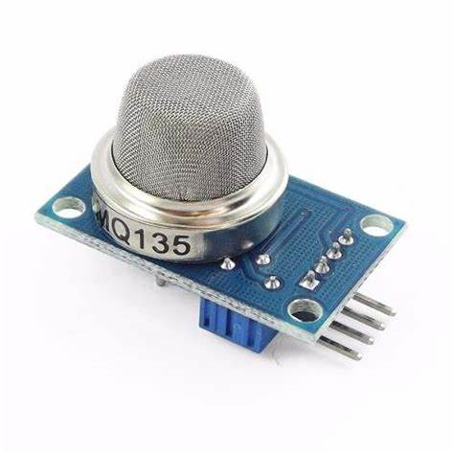

**6. Load cell**

 **Load cell** converts a [force](https://en.wikipedia.org/wiki/Force) such as tension, compression, pressure, or torque into an electrical signal that can be measured and standardized. It is a force [transducer](https://en.wikipedia.org/wiki/Transducer). As the force applied to the load cell increases, the electrical signal changes proportionally. The most common types of load cell are pneumatic, hydraulic, and strain gauges.

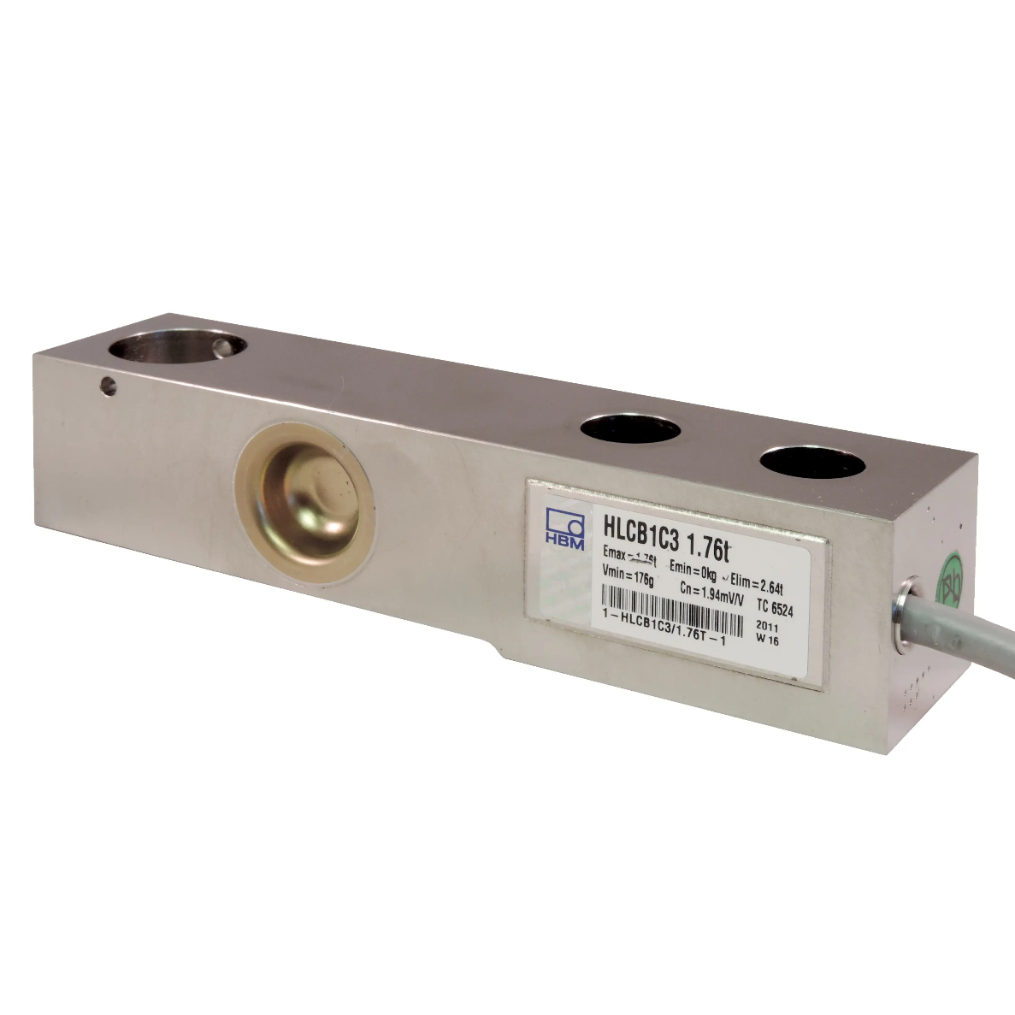

**7.HX711 Driver**

HX711 is a precision 24-bit analog to-digital converter (ADC) designed for weigh scales and industrial control applications to interface directly with a bridge sensor. The input multiplexer selects either Channel A or B differential input to the low-noise programmable gain amplifier (PGA). Channel A can be programmed with a gain of 128 or 64, corresponding to a full-scale differential input voltage of ±20mV or ±40mV respectively, when a 5V supply is connected to AVDD analog power supply pin. Channel B has a fixed gain of 32. On chip power supply regulator eliminates the need for an external supply regulator to provide analog power for the ADC and the sensor. Clock input is flexible. It can be from an external clock source, a crystal, or the on-chip oscillator that does not require any external component. On-chip power on-reset circuitry simplifies digital interface initialization. There is no programming needed for the internal registers. All controls to the HX711 are through the pins.

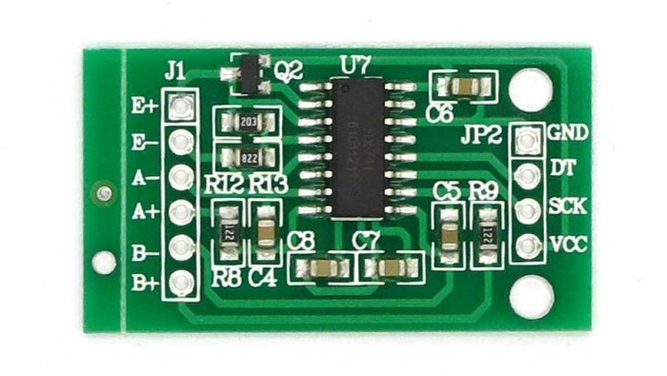

**8.Flame sensor**

A flame-sensor is one [kind of detector](https://www.elprocus.com/emf-detector-circuit-working-types-and-its-applications/) which is mainly designed for detecting as well as responding to the occurrence of a fire or flame. The flame detection response can depend on its fitting. It includes an [alarm system](https://www.elprocus.com/fire-alarm-circuit-using-thermistor/), a natural gas line, propane & a fire suppression system. This sensor is used in [industrial boilers](https://www.elprocus.com/what-is-steam-boiler-working-principle-types-of-steam-boilers/). The main function of this is to give authentication whether the boiler is properly working or not. The response of these sensors is faster as well as more accurate compare with a heat/smoke detector because of its mechanism while detecting the flame.

A sensor which is most sensitive to a normal light is known as a flame sensor. That’s why this [sensor module](https://www.elprocus.com/accelerometer-sensor-working-and-applications/) is used in flame alarms. This sensor detects flame otherwise wavelength within the range of 760 nm – 1100 nm from the light source. This sensor can be easily damaged to high temperature. So this sensor can be placed at a certain distance from the flame. The flame detection can be done from a 100cm distance and the detection angle will be 600. The output of this sensor is an analog signal or digital signal. These sensors are used in fire fighting robots like as a flame alarm.

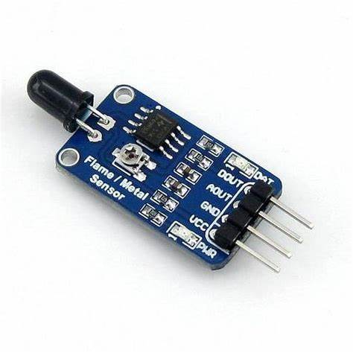

**9. 16*2 LCD**

In LCD 16×2, the term LCD stands for Liquid Crystal Display that uses a plane panel display [technology](https://www.watelectronics.com/what-is-nanotechnology-types-and-its-applications/), used in screens of computer monitors & TVs, smartphones, tablets, mobile devices, etc. Both the displays like LCD & CRTs look the same but their operation is different. Instead of electrons diffraction at a glass display, a liquid crystal display has a backlight that provides [light](https://www.watelectronics.com/how-traffic-light-control-system-works/) to each pixel that is arranged in a rectangular [network](https://www.watelectronics.com/what-is-network-simulation-various-simulators-tools/).

An electronic device that is used to display data and the message is known as LCD 16×2. As the name suggests, it includes 16 Columns & 2 Rows so it can display 32 characters (16×2=32) in total & every character will be made with 5×8 (40) Pixel Dots. So the total pixels within this LCD can be calculated as 32 x 40 otherwise 1280 pixels.

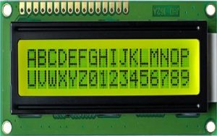

**LCD 16 X2**

16 X2 displays mostly depend on multi-segment LEDs. There are different types of displays available in the market with different combinations such as 8×2, 8×1, 16×1, and 10×2, however, the LCD 16×2 is broadly used in devices, DIY circuits, electronic projects due to less cost, programmable friendly & simple to access.

Specifications of LCD 16X2

The **specifications of LCD 16X2** are discussed below.

* The operating voltage of this display ranges from 4.7V to 5.3V
* The display bezel is 72 x 25mm
* The operating current is 1mA without a backlight
* PCB size of the module is 80L x 36W x 10H mm
* HD47780 controller
* LED color for backlight is green or blue
* Number of columns – 16
* Number of rows – 2
* Number of LCD pins – 16
* Characters – 32
* It works in 4-bit and 8-bit modes
* Pixel box of each character is 5×8 pixel
* Font size of character is 0.125Width x 0.200height

**10 .Buzzer**

An audio signaling device like a beeper or buzzer may be electromechanical or [piezoelectric](https://www.elprocus.com/what-is-a-piezoelectric-material-working/) or mechanical type. The main function of this is to convert the signal from audio to sound. Generally, it is powered through DC voltage and used in timers, alarm devices, printers, alarms, computers, etc. Based on the various designs, it can generate different sounds like alarm, music, bell & siren.

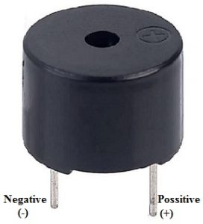

Buzzer Pin Configuration

The **pin configuration of the buzzer** is shown below. It includes two pins namely positive and negative. The positive terminal of this is represented with the ‘+’ symbol or a longer terminal. This terminal is powered through 6Volts whereas the negative terminal is represented with the ‘-‘symbol or short terminal and it is connected to the GND terminal.

**2.3.1 SOFTWARE DESCRIPTION**

The software used here is ARDUINO SOFTWARE:

The Arduino Integrated Development Environment - or Arduino Software (IDE) - contains a text editor for writing code, a message area, a text console, a toolbar with buttons for common functions and a series of menus. It connects to the Arduino and Genuino hardware to upload programs and communicate with them.

Writing Sketches:

Programs written using Arduino Software (IDE) are called sketches. These sketches are written in the text editor and are saved with the file extension ino. The editor has features for cutting/pasting and for searching/replacing text. The message area gives feedback while saving and exporting and also displays errors. The console displays text output by the Arduino Software (IDE), including complete error messages and other information. The bottom righthand corner of the window displays the configured board and serial port. The toolbar buttons allow you to verify and upload programs, create, open, and save sketches, and open the serial monitor.

NB:

Versions of the Arduino Software (IDE) prior to 1.0 saved sketches with the extension pde. It is possible to open these files with version 1.0, you will be prompted to save the sketch with the ino extension on save.

1.Verify

Checks your code for errors compiling it.

2.Upload

Compiles your code and uploads it to the configured board. See uploading below for details.

3.Note:

If you are using an external programmer with your board, you can hold down the "shift" key on your computer when using this icon. The text will change to "Upload using Programmer"

4.New:

Creates a new sketch.

5.Open:

Presents a menu of all the sketches in your sketchbook. Clicking one will open it within the current window overwriting its content.

Note: due to a bug in Java, this menu doesn't scroll; if you need to open a sketch late in the list, use the File | Sketchbook menu instead.

6.Save:

Saves your sketch.

7.Serial Monitor:

Opens the serial monitor.

Additional commands are found within the five menus: File, Edit, Sketch, Tools, and help.

Programming on Arduino uno:

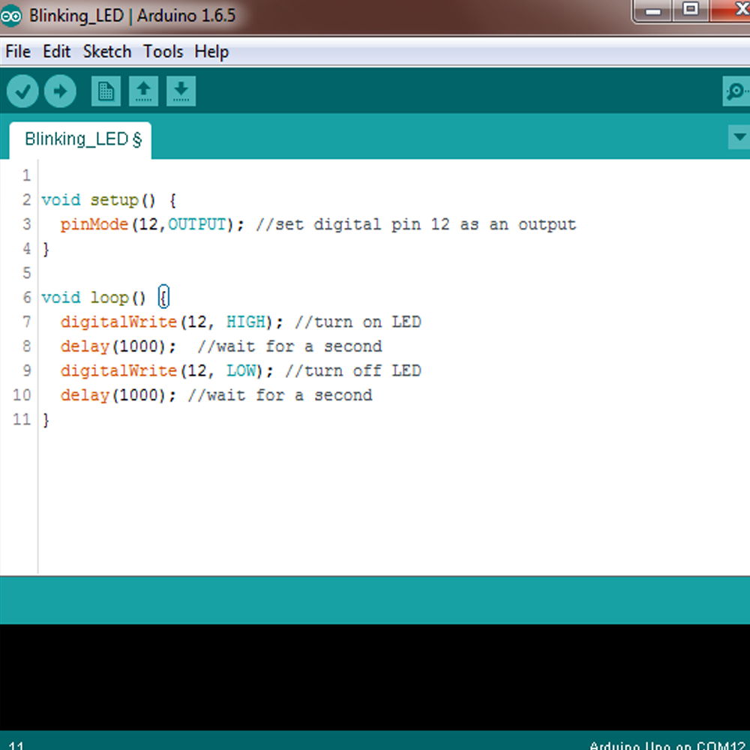

Fig.2.6 Software IDE

In order for the Arduino-Uno board to be able to interact with the application used in this project certain program (code) needs to be uploaded to the Arduino-Uno. Arduino Company provides user friendly software which allows writing any code for any function wanted to be performed by the Arduino-Uno and upload it to the board.Refer to appendix A for the full source code of the Arduino-Uno board.

**3. CIRCUIT DIAGRAM AND DISCRIPTION**

**3.1 Working**

SMART KITCHEN SYSTEM . The system detects the leakage of the LPG using gas sensor and alerts about the gas leakage through buzzer and opens the window . The system measures the weight of cylinder by using weight sensor(load cell) and display corresponding weight in LCD display. Amount of gas is known by measuring the weight of gas cylinder. To measure the weight, Load cell a weight sensor is used. It continuously measures the weight of the cylinder and displays. MQ135 gas sensor is used to sense the gas leakage.MQ135 sensor module can detect LPG, smoke, alcohol, hydrogen gas.Fire sensor is also used It detects the fire and passes the information to Arduino uno then it displays in LCD and alerts about the fire detection through buzzer. The main aim of this project is to monitor for liquid petroleum gas (LPG) leakage to avoid major fire accidents and also facilitating safety precautions

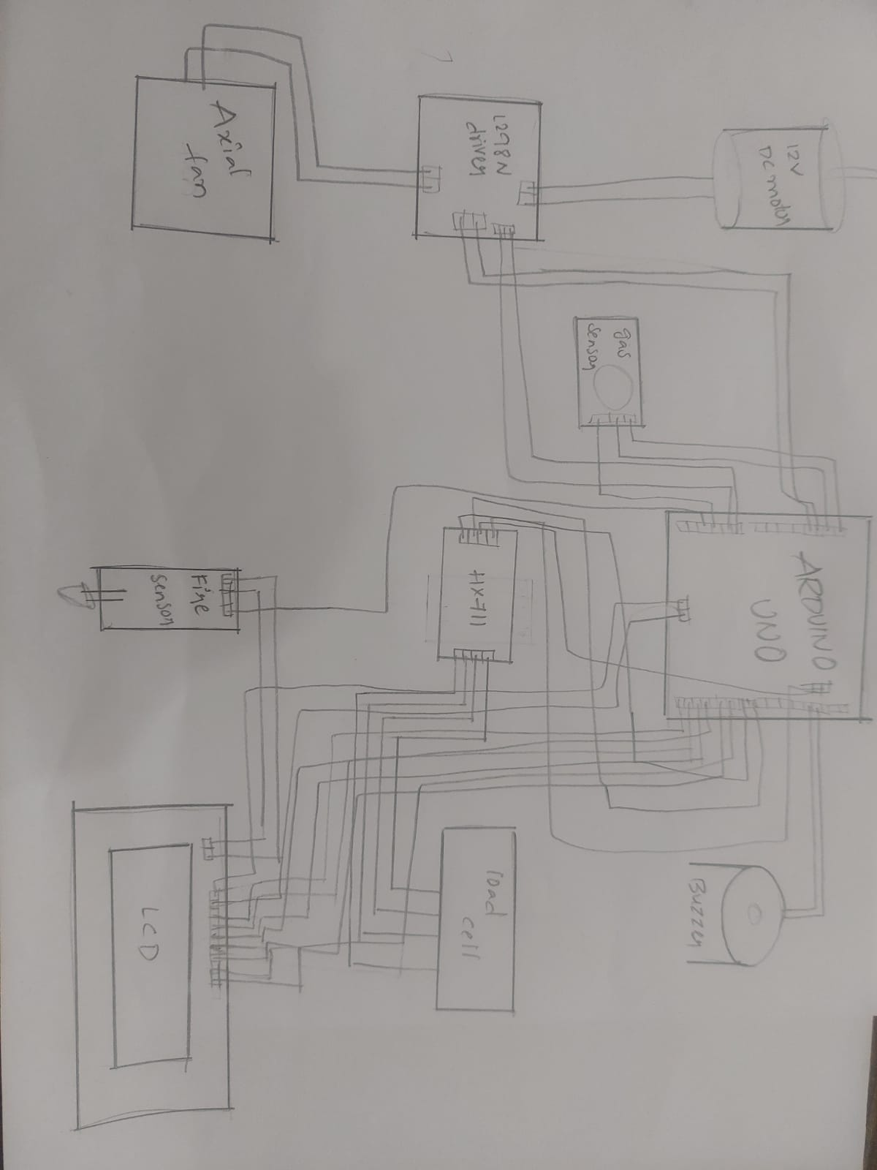

**3.2 Result**

A system prototype has been built and all the modules of the system are working according to the desired requirement. According to our first module, when the gas sensor senses the presence of LPG in air, it detects the leakage, it displays information on LCD about leakage and alerts through buzzer. The proposed system also continuously measures the gas level in the cylinder.And also it detects fire and alerts through lcd and buzzer.

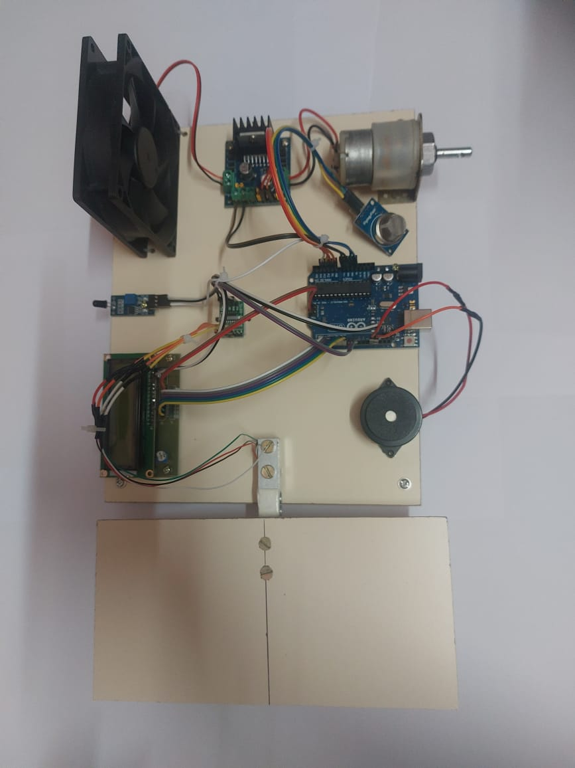

**3.3 Advantages**

• It detects gas level in cylinder.

• It uses weight sensor to continuously record the LPG level in the cylinder.

• It detects the fire.

• It gives signal as buzzer when gas is leaked or fire accident happens.

**3.4 Disadvantages**

• Sometimes the sensor get damage and it may not work.

• Equipment and installation cost.

• Some times it gives small error in measuring of exact value of LPG gas.

**4. CONCLUSION**

**4.1 CONCLUSION**

In this project we have considered different aspects of LPG leakage and weight monitoring mechanism and came up with a cost-effective and systematized procedure . The recommended system constantly calculates the concentration of LPG in the air and weight of the cylinder to achieve the intended target. This system is also capable of detecting fire and alerting.Apart from all the above functionalities it also includes different alert mechanisms such as LCD display, buzzer and alert system which make the system more accurate and efficient. It is an advantageous and well-organized system which can be used in home as well as in industry to prevent any calamity which may happen due to LPG leakage.

**4.2 Future scope**

This monitoring system can prevent fire accidents, which supports the another real-time application. Addition of load cell can also be used as pressure sensor which detects the amount of gas in the cylinder and also detects high pressure gas in cylinder pipe, displaying the alert message through LCD displays.

**BIBLIOGRAPHY**

**1.**[**https://www.bing.com/ck/a?!&&p=b2b1db9c103f918eJmltdHM9MTY3NDg2NDAwMCZpZ3VpZD0wYzJjOGIzNC1hYzk4LTY5YmMtMjkyMS05OTU2YWQ3MDY4NGMmaW5zaWQ9NTE4OQ&ptn=3&hsh=3&fclid=0c2c8b34-ac98-69bc-2921-9956ad70684c&psq=%2blpg+gas+monitoring+system+arudino+&u=a1aHR0cHM6Ly93d3cuaWppcnQub3JnL21hc3Rlci9wdWJsaXNoZWRwYXBlci9JSklSVDE1MTAwMl9QQVBFUi5wZGY&ntb=1**](https://www.bing.com/ck/a?!&&p=b2b1db9c103f918eJmltdHM9MTY3NDg2NDAwMCZpZ3VpZD0wYzJjOGIzNC1hYzk4LTY5YmMtMjkyMS05OTU2YWQ3MDY4NGMmaW5zaWQ9NTE4OQ&ptn=3&hsh=3&fclid=0c2c8b34-ac98-69bc-2921-9956ad70684c&psq=%2blpg+gas+monitoring+system+arudino+&u=a1aHR0cHM6Ly93d3cuaWppcnQub3JnL21hc3Rlci9wdWJsaXNoZWRwYXBlci9JSklSVDE1MTAwMl9QQVBFUi5wZGY&ntb=1)

2.<https://youtu.be/gRHXBzrVHUE>

3.<https://youtu.be/iC-umvkXeFA>